

Practices for Secure Software Report

Table of Contents
Document Revision History 3
Client 3
Instructions 3
Developer 4
1. Algorithm Cipher 4
2. Certificate Generation 4
3. Deploy Cipher 5
4. Secure Communications 5
5. Secondary Testing 5
6. Functional Testing 6
7. Summary 6
8. Industry Standard Best Practices 7

Document Revision History

Version | Date | Author | Comments
1.0 | 5/27/2026 | Robert Sanchez

Client



Instructions

Submit this completed practices for secure software report. Replace the bracketed text with the relevant information. You must document your process for writing secure communications and refactoring code that complies with software security testing protocols.

- Respond to the steps outlined below and include your findings.
- Respond using your own words. You may also choose to include images or supporting materials. If you include them, make certain to insert them in all the relevant locations in the document.
- Refer to the Project Two Guidelines and Rubric for more detailed instructions about each section of the template.

Developer
Robert Sanchez

Algorithm Cipher

SHA-256 was selected as the cryptographic hash algorithm for the Artemis Financial application. SHA-256 is part of the SHA-2 family of secure hashing algorithms developed by the National Security Agency (NSA). The algorithm generates a 256-bit hash value that is commonly used for secure checksum verification and data integrity validation.

SHA-256 is considered secure because it is resistant to collisions and brute-force attacks. The checksum generated by SHA-256 helps verify that transferred data has not been modified or tampered with during communication. The application also uses HTTPS secure communication through SSL/TLS certificates to encrypt data between the client and server.

The project uses both symmetric and asymmetric encryption concepts. RSA asymmetric encryption is used within the SSL certificate exchange process to establish secure communication channels. After the secure session is established, symmetric encryption is used for efficient encrypted communication during the session.

Modern encryption algorithms continue to evolve as computing power increases and security threats become more advanced. SHA-256 remains one of the most widely trusted and commonly implemented hashing algorithms in modern cybersecurity practices.

Certificate Generation
Insert a screenshot below of the CER file.

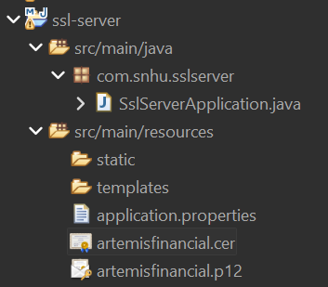

Deploy Cipher
Insert a screenshot below of the checksum verification.

The application was refactored to implement SHA-256 checksum verification. A secure hash value is generated from a unique data string using Java MessageDigest functionality. The checksum verifies the integrity of transferred data and helps detect unauthorized modifications.

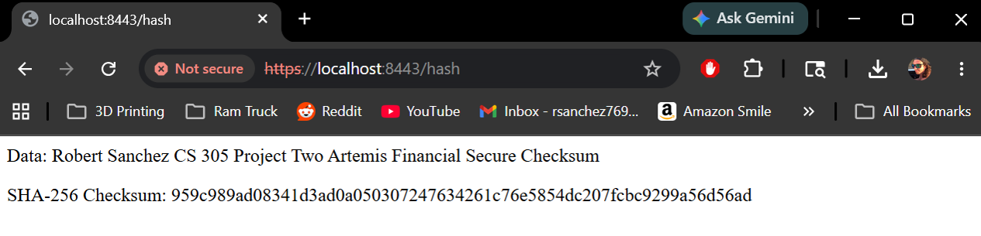

Secure Communications
Insert a screenshot below of the web browser that shows a secure webpage.

HTTPS secure communication was successfully implemented by configuring Spring Boot to use SSL/TLS encryption on port 8443. A self-signed certificate generated through Java Keytool was added to the application resources and configured within the application.properties file.



Secondary Testing
Insert screenshots below of the refactored code executed without errors and the dependency-check report.

OWASP Dependency-Check was integrated into the Maven build configuration to analyze dependencies for known vulnerabilities. The dependency-check plugin successfully initiated vulnerability scanning and dependency analysis. During execution, the tool encountered external NVD database synchronization and connection issues which prevented completion of the scan. The issue was related to dependency-check database processing rather than vulnerabilities introduced within the refactored application code.

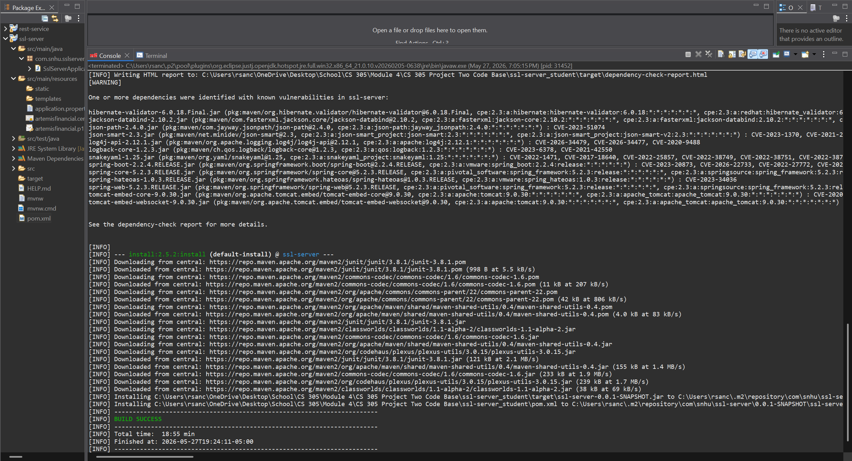

Functional Testing
Insert a screenshot below of the refactored code executed without errors.

Functional testing was performed by compiling and executing the refactored Spring Boot application. Testing confirmed that the application executed successfully without runtime errors and that secure HTTPS communication functioned properly. The SHA-256 checksum verification endpoint also generated the expected output successfully.

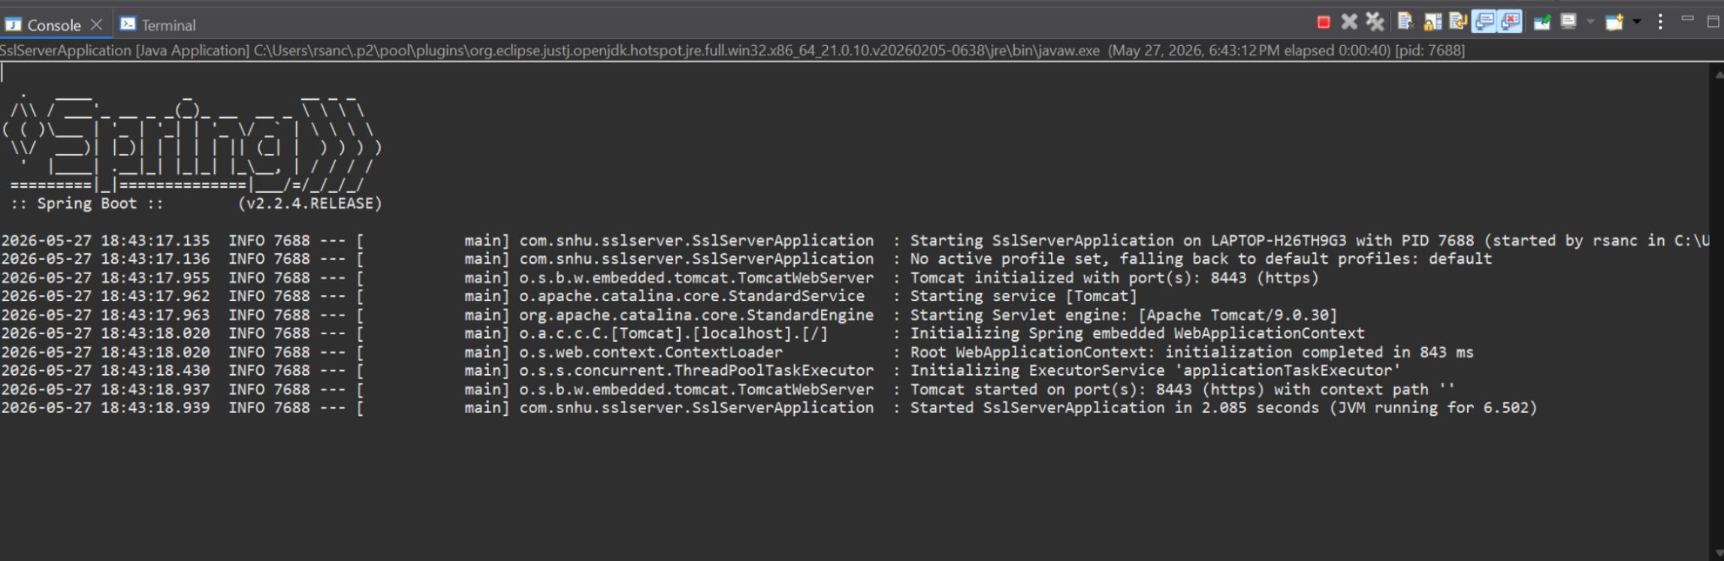

Summary

The Artemis Financial application was refactored to improve software security and secure communications. HTTPS was implemented using a self-signed SSL certificate generated through Java Keytool. A SHA-256 checksum verification feature was added to verify data integrity during transmission. The application properties were updated to force secure communication over port 8443.
Functional testing confirmed the application executed successfully without runtime errors. Dependency-check testing was integrated into Maven to analyze dependencies for known vulnerabilities. These updates improved the application’s protection against insecure communications and data tampering.
The refactoring process addressed several areas of the vulnerability assessment process, including secure communications, encryption, dependency analysis, secure configuration management, and integrity validation. Multiple layers of security were added to help protect sensitive financial information transmitted through the application.

Industry Standard Best Practices

Industry standard secure coding practices were applied throughout the project to improve application security. HTTPS encryption was enabled to protect data transmitted between the client and server. SHA-256 hashing was implemented to verify data integrity and detect tampering. Dependency-check was integrated into the Maven build process to identify known dependency vulnerabilities.
Secure coding best practices help organizations reduce security risks, protect customer information, maintain regulatory compliance, and improve software reliability. Applying layered security controls also helps defend against common cybersecurity threats such as data interception, unauthorized modification, and insecure communications.

